Golf Course Manager - Deployment

# Setting up the Azure Database

1. Open the Azure Portal.
2. Add a new SQL server instance. You will likely have to use a different server name.

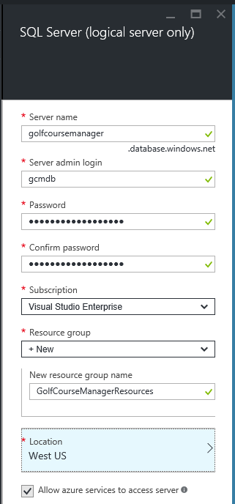

1. Using Visual Studio 2015 Server Explorer, sign in to your Azure profile.

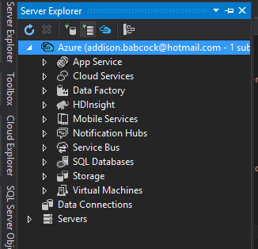

1. Connect to the new database server with the SQL Server Object Explorer.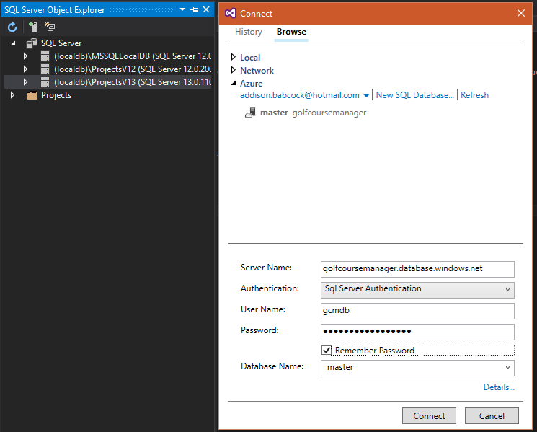
2. Create the database using the Server Object Explorer.

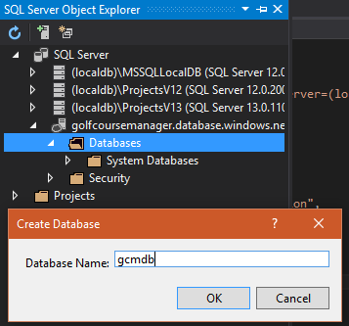

1. In the Azure Portal, copy the ADO.NET connection string for the newly created database.

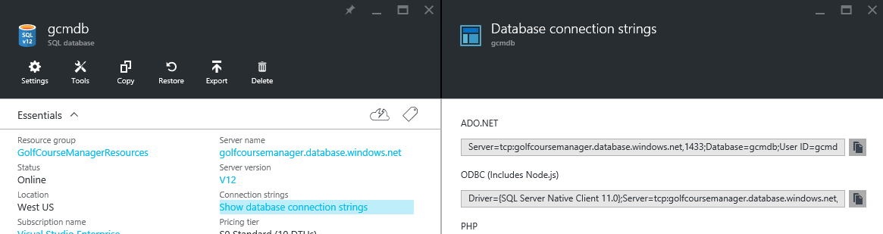

1. Paste the connection string in to the appsettings.json file over top of the existing connection string. You will have to change the password in the connection string.

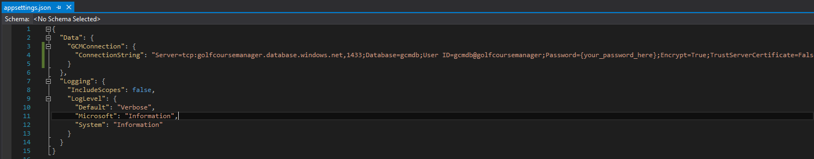

1. Use the Package Manager Console to run Entity Framework Migrations. See the Getting Started document for further details.

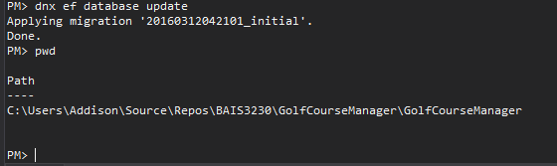

# Set up the Azure Web App

1. Back in the Azure Portal, create a new Web App.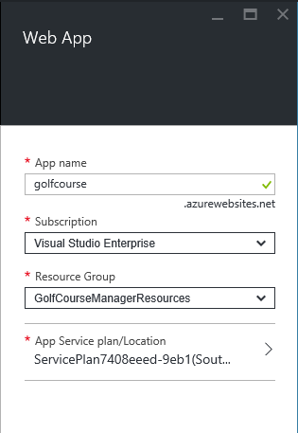
2. Set up the publishing profile. Right click on the GolfCourseManager project in Visual Studio. Click on Publish… Click on Azure App Service.
3. Select your Web App from the list. 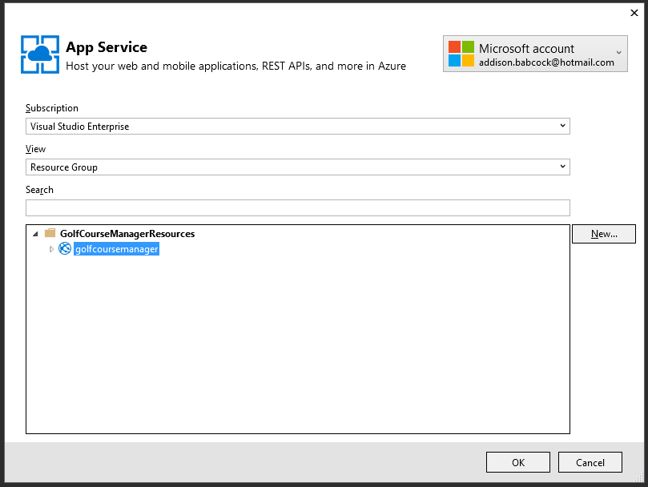
4. From there, the rest of the defaults in the profile are likely fine. Click the Publish button to save the profile and publish the project.
5. The publish step will attempt to launch the site.